State the question / problem / objective: This lab was set up to help use understand natural selection and the characteristics of a niche in biotic and abiotic. This lab addresses these objectives through by observing and taking notes on a transact in nature and by us taking samples and setting them up thus allowing us to look at them next time. The topography of the of the transect is grass, rocks, cement and mud on a slight slant.
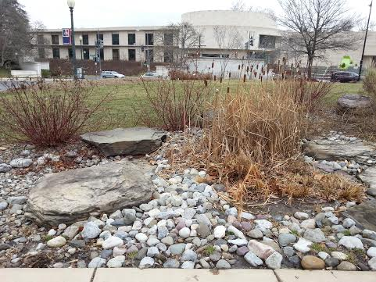
Record the specific steps you performed:
- To start the lab a 20 by 20 feet dimensions are measured for a transact which is marked by putting a popsicle stick in each corner.
- Once the transact is layed out it should be noted the location to begin then topography among other obserations.
- Observe and write down in a list the abiotic and biotic components in the transact.
- Sample should be taken of the soil and ground vegetation using a sterile 50 ml conical tube. Its key to make sure to get reprehensive of the ground
- Stay at the transact until the instructor has checked your work and said to go
- 10 to 12 grams of the sample should be weighed out and placed in a plastic jar. The plastic jar should also contain 500 mls of deer park water.
- Then add in 0.1gm of dried mild. Once added the jar should be gently mixed up for 10 seconds.
- Once mixed the led should be removed and the jar should be placed in a safe place
- Be sure to label the jar clearly.

Table 1 Evolutionary Specialization of Members of the Volvocine Line:
Characteristic | Chlamydomonas | Gonium | Volvox
Number of cells | 1 | 5 | 3
Colony size | 25 | 4 | 2.5
Describe any functional specialization of cells | “There are some 500 species of Chlamydomonas, found in soil, ponds, and ditches, where they may colour water green. One species, C. nivalis, which contains the red pigment hematochrome, sometimes imparts a red colour to melting snow.” | “Each cell has a central nucleus and two or four flagella protruding from an opening in the anterior end of the closely fitting cellulose wall. Chromatophores contain green pigments. Sexual reproduction occurs by isogamy, anisogamy, or oogamy.” | “ Volvox exhibits differentiation between somatic and reproductive cells, a phenomenon considered by some zoologists to be significant in tracing the evolution of higher animals from Protozoa. Certain species, in which somatic cells appear to be joined by cytoplasmic strands, may be considered as multicellular organisms. “
Describe any reproductive specialization (isogamy vs oogamy) | Asexual reproduction  And sexual reproduction | Sexual reproduction | Both asexual reproduction and sexual reproduction

List of Biotic abiotic organisms:
Abiotic | Biotic
-Rocks  -Soil  -Dead leaves  -Sidewalk  -littering | -Sun shine /light  -Worms  -Plants(Tall grass/weeds /grass/etc.)  -Alogy moss and rock fungus  -Air/Water  -Birds/ humans  -Bacteria

State Conclusions and future plans:
The goal of this lab was to help use understand natural selection and the characteristics of a niche in biotic and abiotic. We where able to observe natural selection by looking at the animals that are still around . Biotic and abiotic organisms where observed by observing the transects and identifying what was abiotic and biotic. I don’t know how but if we did this experiment again and one of the goals was to understand natural selection then I would find away to make the goal more clearly understood. Though nothing went wrong many things could of including messing up the mixing of the jar. Something that would be interesting to see if we did is to take samples in different temperatures and weather conditions to see how that would change our results. The different variables would add more veriaty to the results thus giving us a better understanding of the life that the transect supports

Bentley/Walters-Conte/Zeller. (2014). Biological Life at AU. AU.

Chlamydomonas. (2014). In Encyclopaedia Britannica. Retrieved from http://www.britannica.com/EBchecked/topic/113450/Chlamydomonas

Nozaki, H. (1986). Sexual reproduction in gonium sociale (chlorophyta, volvocales). Phycologia, 25(1), 29-35. Retrieved from http://search.proquest.com/docview/14780095?accountid=8285

volvocid. (2014). In Encyclopaedia Britannica. Retrieved from http://www.britannica.com/EBchecked/topic/632667/volvocid

Volvox. (2014). In Encyclopaedia Britannica. Retrieved from http://www.britannica.com/EBchecked/topic/632669/Volvox

