
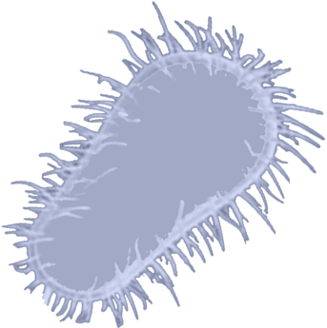

University of Calgary iGEM
This year’s project
The wetlab aspect for our project aims to engineer and characterize a novel Autoinducer-2 (AI-2) signalling system in E. coli for the study of cell-to-cell communication. This year’s iGEM project is designed to target and prevent the formation of biofilms. Bioflims are an accumulation of microorganisms in nature which could potentially become problematic when bacteria begin to accumulate and clog up industrial pipelines. To form biofilm, bacteria communicate with other members of its colony. This year’s students engineered a gene in E.coli to break down bacterial communication to prevent the formation of biofilms. This not only helps to clean up pipelines but also prevents further biofilm formation.

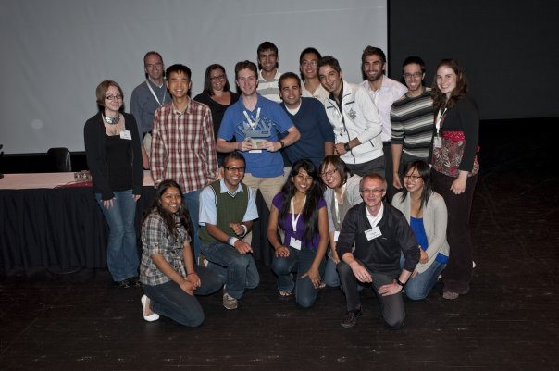

iGEM Calgary has also used computer modelling to interpret cellular behavior, analyzed ethical challenges posed by new capabilities in biological engineering and created a 3D virtual world on Second Life to help educate high school and undergraduate students about possible future applications for genetic engineering.

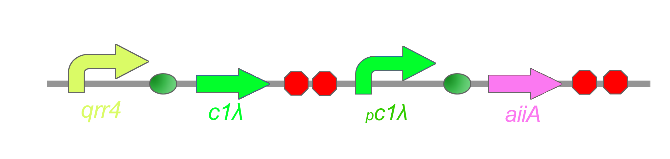
R
R
LuxO
P
σ⁵⁴

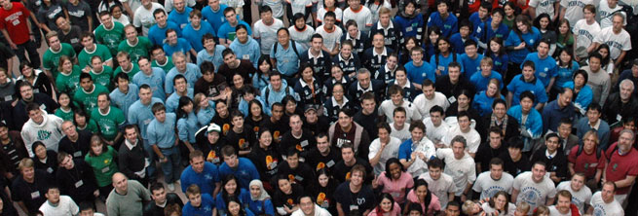
University of Calgary iGEM Team

University of Calgary
Health Science Centre
3330 Hospital Drive NW.
Calgary AB T2N 4N1
(403) 210-8704

http://2009.igem.org/Team:Calgary




Information Brochure

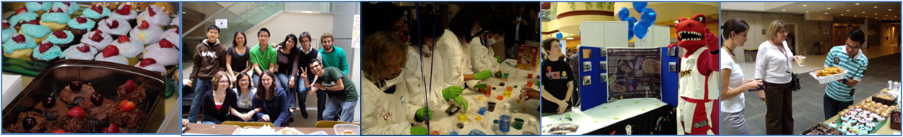
What is iGEM?
The international Genetically Engineered Machines (iGEM) completion is an annual undergraduate Synthetic Biology competition. Student teams are given a kit of biological parts at the beginning of the summer from the Registry of Standard Biological Parts. Working at their own schools over the summer, they use these parts and new parts of their own design to build biological systems and operate them in living cells. This project design and competition format is an exceptionally motivating and effective teaching method.

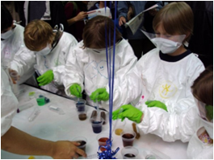
TARGET
BUSIN
ESS CONSULTING

iGEM 2009 Agenda

What: the iGEM Jamboree

When: Saturday October 31, Sunday November 1, & Monday November 2. The public is invited to attend the awards ceremony on Sunday beginning at 8am, on a space available basis.

Where: Saturday & Sunday in MIT (Massachusetts Institute of Technology, Boston, USA) Stata Centre and Lobby 13 & Monday in Kresge Auditorium

What does it take to join iGEM?

Simply interest and dedication! All the background biology and introduction to new terminology, laboratory techniques and concepts will be introduced to you in the beginning of the summer. Besides, lab is only ONE of the several aspects of iGEM. Interested students from various background may choose to pursue marketing initiatives to raise sponsorship to fund the project or join the Second Life team to build a 3D virtual world to teach future students about Synthetic biology or join the modeling team to analysis of the biological cells using computer models.

Elementary students took part in afierce Pipetting competition at the iGEM booth during Campus Fair (June 6, 2009).

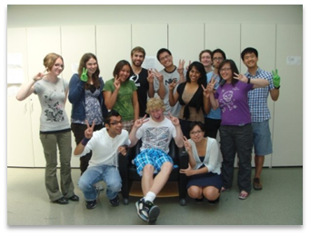
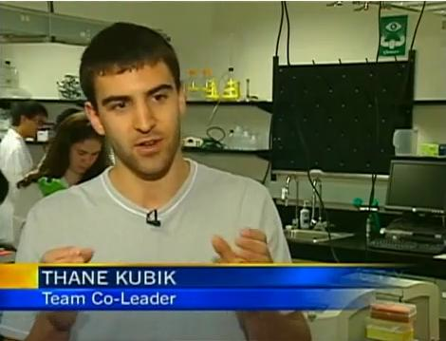
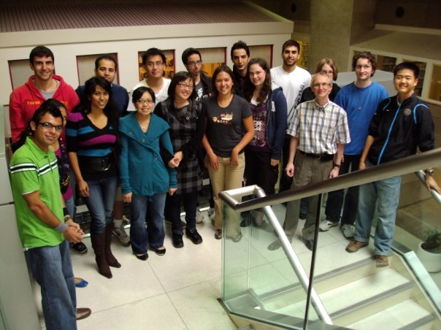
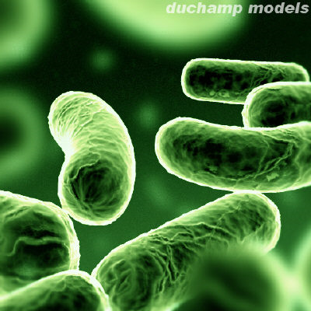
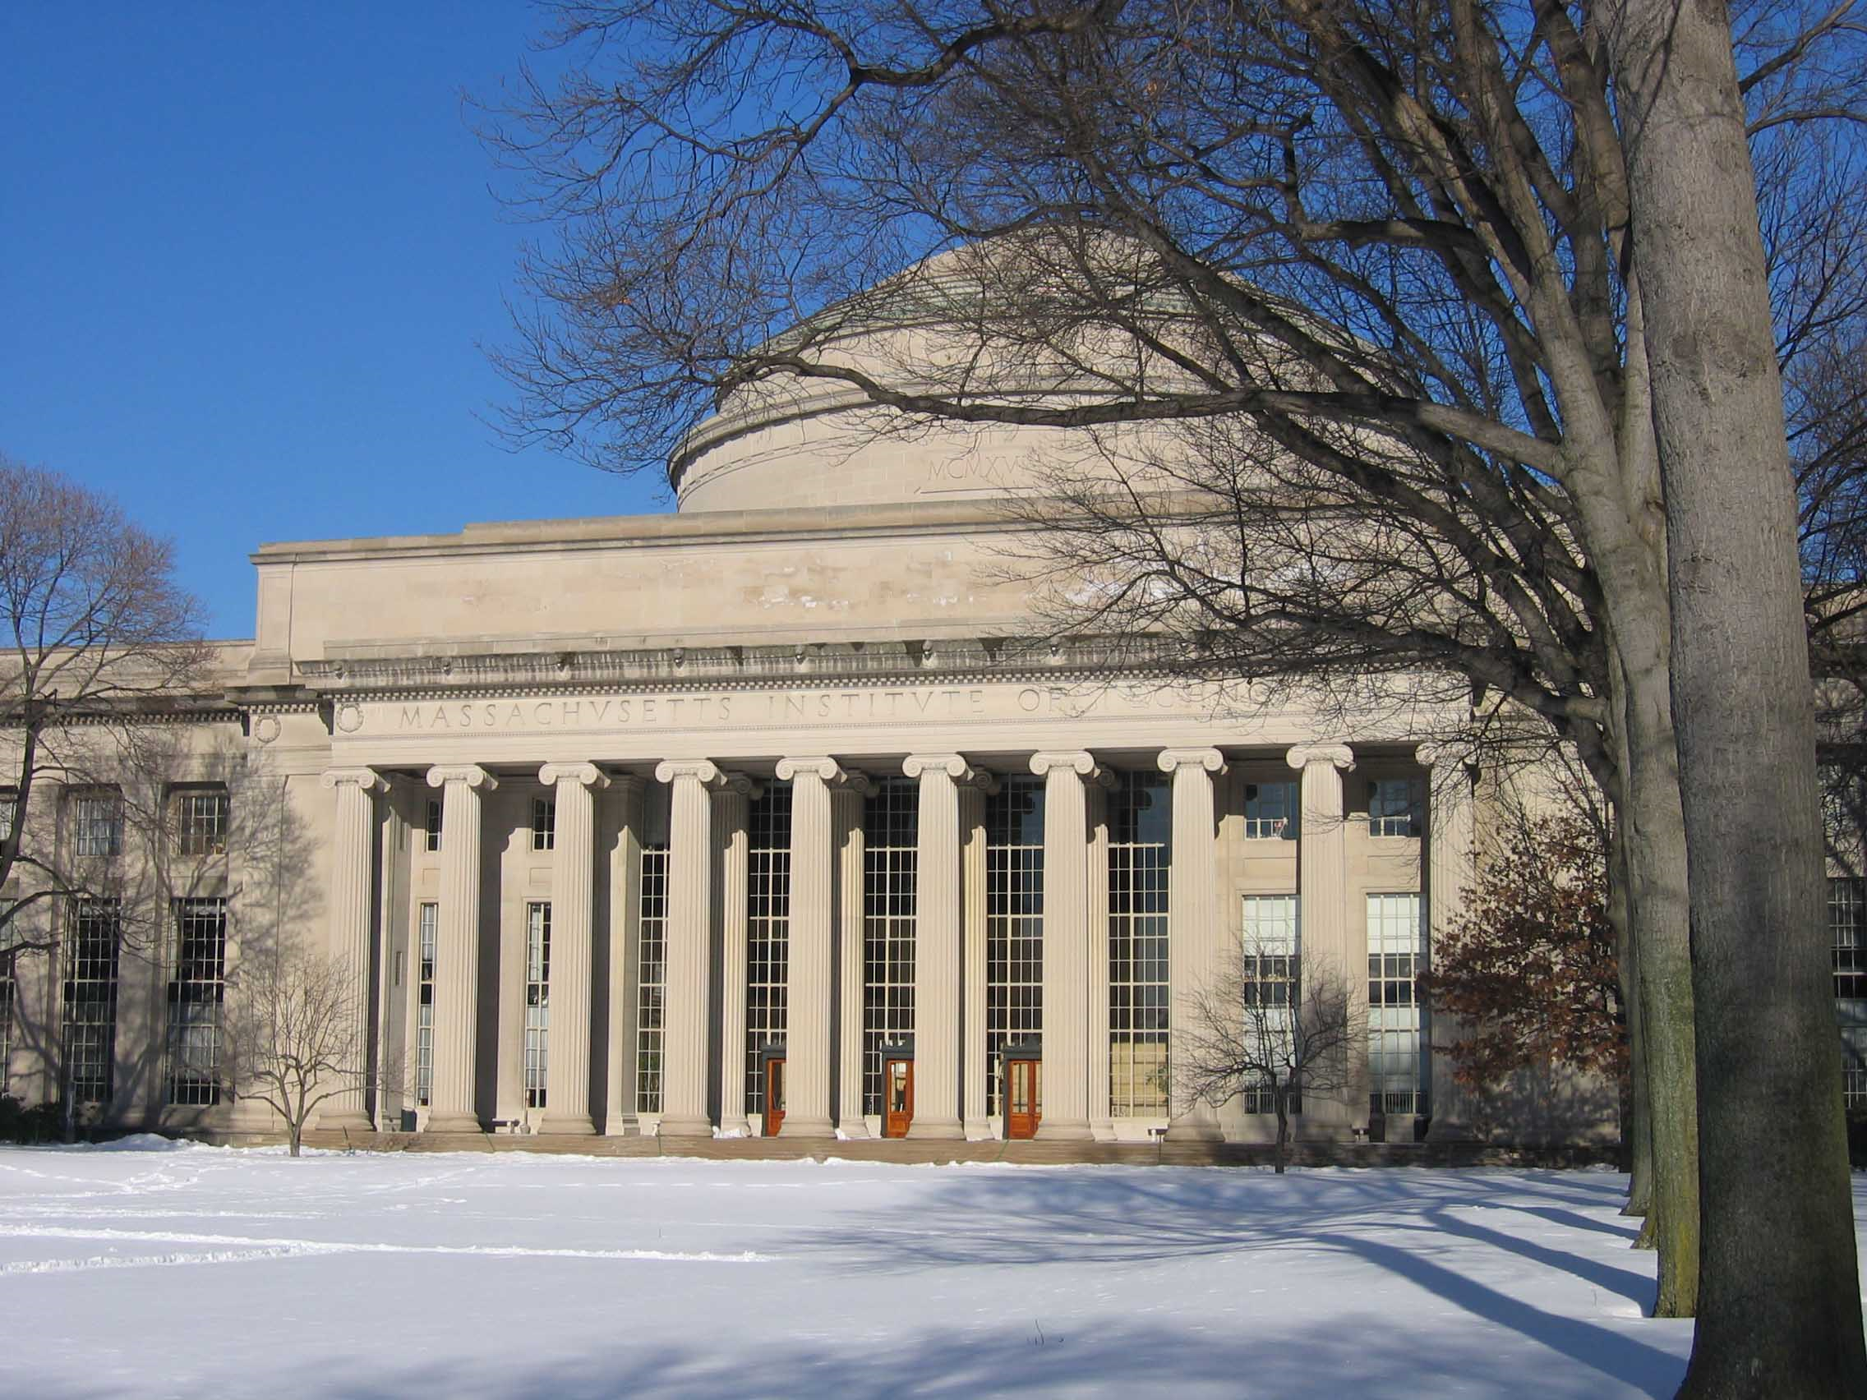
Synthetic Biology is a new approach to engineering biology, with an emphasis on technologies to manipulate DNA. Similar to how softwares are built to program computers, standarization of DNA-encoded parts and devices enables them to be combined to create programs to control cells.

What is
Synthetic Biology?

- Build your own project
- Undergraduate level research opportunity
- Chance to compete internationally
- Become a member of an interdisciplinary team
- Looks great on your resume

Why should I care?
A team picture with a highschool student who took part in the iGEM summer camp to gain practical experiences in the lab.

Co-team leader, Thane Kubik featured on CTV News June 3rd 2009 for iGEM broadcast.

