August 2nd
We started the eighth 23hr-annealing according to the parameters used in July 13th.

August 3rd
A 2% agarose gel electrophoresis was conducted. Photo was captured, and the target bands were excised and undergone gel extraction according to the protocol (see methodology). After gel extraction, the concentration of DNA was determined by Nanodrop:
DNA Concentration | 5.5 ng/µL = 47.94 nM
260/280 | 3.63
260/230 | 0.01

Result of the gel electrophoresis:
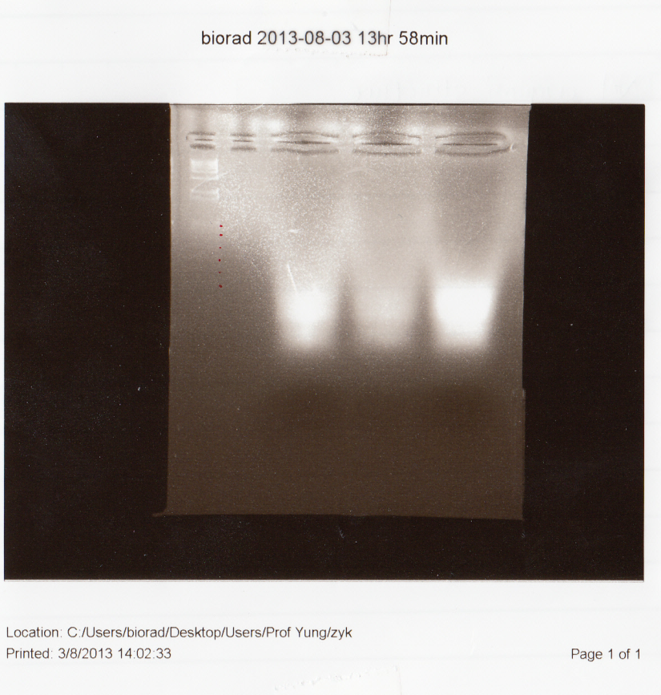
According to the results and many annealing assays in the past two months, the target bands were not well separated from the excess staples. After discussion, we decided to make several adjustments:
- Lower the density of agarose gel from 2% to 1.5% to obtain a faster speed;
- Increase the voltage from 70V to 90V to obtain a faster speed;
- Instead of the 1kb DNA ladder, use the 100bp DNA ladder for electrophoresis
We also noticed that a very low 260/230 ratio was obtained after gel extraction, which is around 0.01 to 0.03. Since the purity of the sample is crucial for the subsequent assay, further purification is required.
Moreover, we consulted Shawn Douglas about the problems of synthesizing DNA origami, and we read in more details about the relevant knowledge. After consideration, we decided to design a new small DNA origami, reducing the number of scaffold strands to avoid nonspecific coupling.

August 4th
We contacted Mr. Fang Yuqiang at City University of Hong Kong and arranged the AFM imaging on Friday (August. 9th)

August 7th
We designed the second structure of DNA origami (See methodology) and settled the order for Tech Dragon Limited, Hong Kong. No further annealing assay will be conducted until the new scaffold and staples arrive.

August 8th
3 slides for AFM imaging were prepared as follow:
Slides | Content
1 | 4 nM DNA in buffer
2 | 4 nM in MQ water
3 | Buffer control

August 9th
Result of AFM imaging
DNA (1), Size scale: 5.0 µm×5.0 µm; Height scale: -6.0nm – 6.0nm.
DNA (2), Size scale: 1.0 µm× 1.0 µm; Height scale: -6.0nm – 6.0nm.
According to the AFM scanning, aggregation effects are most possibly happened between DNA origami molecules assisted by buffer, which lead to the relatively large size appeared in the image.

August 16th
The new scaffold and staple strands arrived today, thus we started the tenth 23hr-annealing according to the parameters shown below:
Component | Concentration (µM) | Volume (µL)
1 | 1 | 2
2 | 1 | 2
B3 | 1 | 2
B4 | 1 | 2
5 | 0.2 | 1
20X DFB | / | 2.5
RNase free H₂O | / | 38.5
Total |  | 50

August 17th
A 1.5% agarose gel electrophoresis was conducted today. Photo was captured. However, no bands were shown in the image, therefore we did not conduct gel extraction.
After discussion, we decided to lower the size of the wells on the agarose gel.
Result of gel electrophoresis:
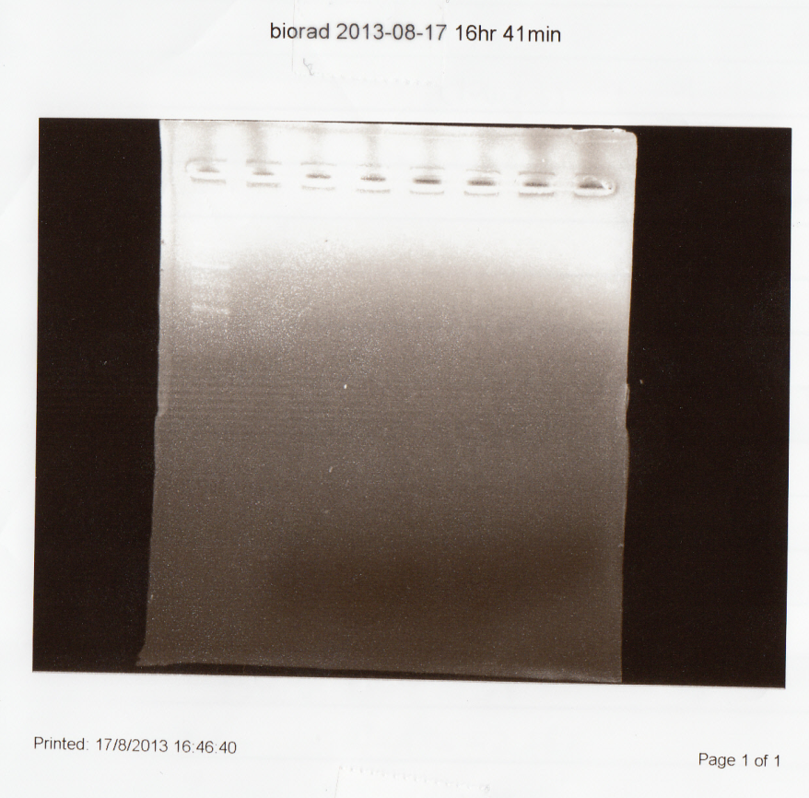
August 18th
We conducted the eleventh 23-annealing with the same parameters as the tenth annealing process.

August 19th
A 1.5% agarose gel electrophoresis was conducted, and a photo was captured.
Result of gel electrophoresis:
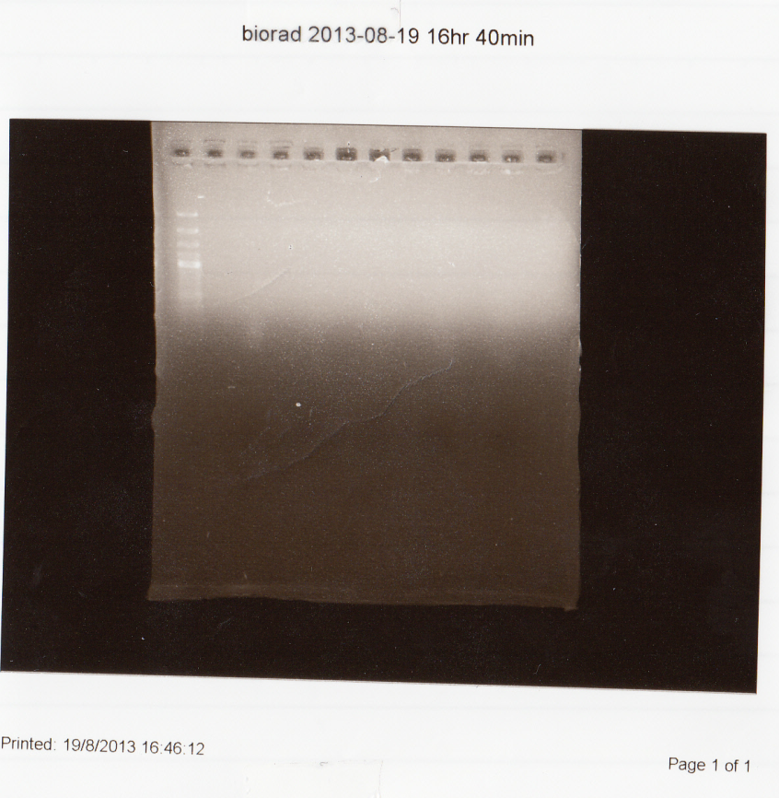
Very faint bands were observed around the 100-200bp position; therefore, no further experiments were conducted. We decided to raise the concentration of staples in the next annealing.
We conducted the eleventh 23hr-annealing according to the parameters shown below:
Component | Volume (μL) | Final concentration (μM)
20X DFB | 2.5 | /
1 | 10 | 2
2 | 10 | 2
B3 | 10 | 2
B4 | 10 | 2
Scaffold | 1 | 0.2
RNase free H₂O | 6.5 | /
Total | 50 | /

August 20th
A 1.5% agarose gel electrophoresis was conducted. Photo was captured, and the target bands were excised and undergone gel extraction according to the protocol (see methodology). After gel extraction, the concentration of DNA was determined by Nanodrop:
DNA Concentration | 3.4 ng/µL
260/280 | 1.81
260/230 | 0.01
Result of gel electrophoresis:
Judging from the image, the bands were clearer than those in the tenth and eleventh annealing, but the brightness is still far from satisfactory. We decided to amplify the amount of scaffold and staples in a larger scale.
Calculation for Amplification
For the annealing assays later on, both the concentrations of scaffold and staples will be raised, in which the scaffold will increase from 0.2μM to 1.3μM, and the staples will increase from 1μM to 13μM.
Quantitative part:
MW (new structure) = 172 bp
Other sample: 14493bp (rectangle, Rothemund 2006); 15386bp (star, Rothemund 2006)
Average: 15000bp
MW (first model) = 372bp
372/172=2.162
Suggested amplification rate: 3X~10X, which means:
- New scaffold concentration: 0.2µM[0.6µM, 2µM]
- New staple concentration: 2µM[6µM, 20µM]
Thus, we take the average value: Conc_{(scaffold)}=1.3µM; Conc_{(staple)}= 13µM.

August 23rd
We conducted the twelfth 23hr-annealing according to the parameters shown below:
Component | Final concentration | Volume (μL)
1 | 13μM | 6.5
2 | 13μM | 6.5
B3 | 13μM | 6.5
B4 | 13μM | 6.5
Scaffold | 1.3μM | 0.65
20X DFB | / | 2.5
RNase free H₂O | / | 20.8
Total |  | 50

August 24th
A 1.5% agarose gel electrophoresis was conducted. Photo was captured, and the target bands were excised and undergone gel extraction according to the protocol (see methodology). After gel extraction, the concentration of DNA was determined by Nanodrop:
DNA Concentration | 10.4 ng/µL
260/280 | 2.00
260/230 | 0.03
Result of gel electrophoresis:
Clear bands were achieved around the 100-200bp position. The sample will be stored and proceed to purification on Sept. 2nd according to the protocol (see methodology).

