Lab Plans and Actions for Week 8/18/08-8/24/08
Scientist | Report (8/18/08) | Plans (8/19-8/27)
N Spencer | - Antibody project  - Did immunos and imaged collagen II, decorin, cochlin, CD9, myelin, cyclophilin.  - Stored newest data on external hard drive.  - Received external hard drive  - Collagen II, decorin and cochlin labeled the basement membrane.  - CD9 did not work; it is worth trying again with a modified protocol or different antibody.  --Myelin P2 only labeled nerve, and I do not think it is worth trying again.  --I messed up the cyclophilin experiment. | “I w  -I will be out from 8/20-8/26!  -I have used 14 of the 20 requested confocal hours.  - Antibody project  --Repeat cyclophilin (5 min Triton vs 5 min triton/control vs no triton vs no triton/control).  --Image Cyclophilin when I get back on the 27th.  --Order new antibodies  - Regen project  --Finish Imaging Myosin 7a/To-Pro controls (72h, 144h).

Santa Cruz biotechnology Cochlin monoclonal antibody

Relevance: Cochlin is a basement membrane protein that has been reported in the mammalian but not avian inner ear. Mutations cause deafness.
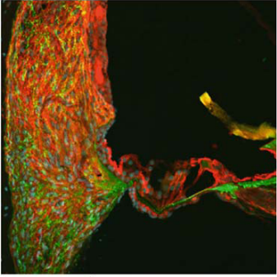
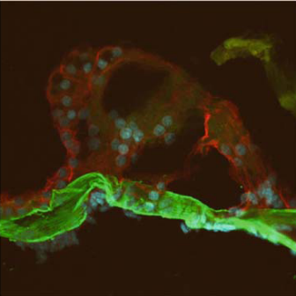

JARO 8: 435–446 (2007) (above)

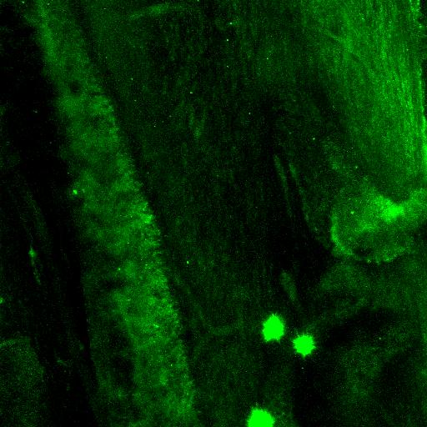
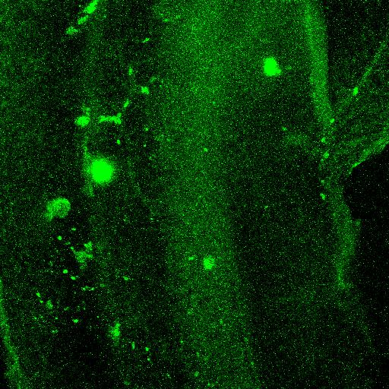
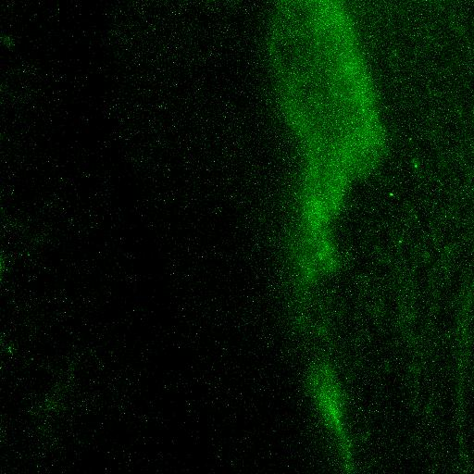
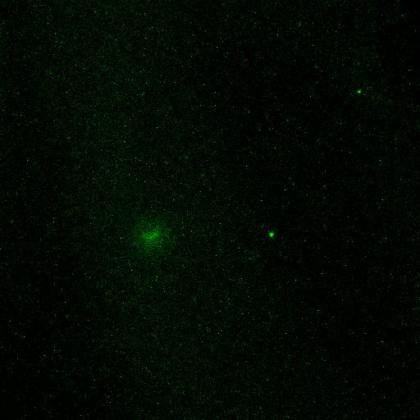
A

B

C

D

Procedures: Used whole ear. Methanol fix (-20C, 10 minutes), Triton permeabilization (10 minutes, R.T.).

Results:
20x:
-With Cochlin antibody (A): Bright basement membrane labeling.
-Secondary alone control (B): Back-groundy basement membrane labeling.
40x:
-With Cochlin antibody (A): Moderate basement membrane labeling.
-Secondary alone control (B): Very little basement membrane labeling.

Analysis: I believe that the Cochlin antibody worked. I need to repeat this experiment, with isolated basement membrane tissue to see if the same result occurs. I had a little bit of difficulty telling what was basement membrane and what was not. The phalloidin hair cell label did not work with methanol fixation.

A

B

C

CD-9 ROCA-2 monoclonal antibody

Relevance: CD-9 is a cell surface glycoprotein. It has been implicated in cellular signaling growth and differentiation in the hematopoietic and nervous systems (J Neurosci 1997; 17(8): 2756-65.
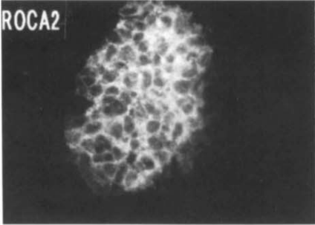
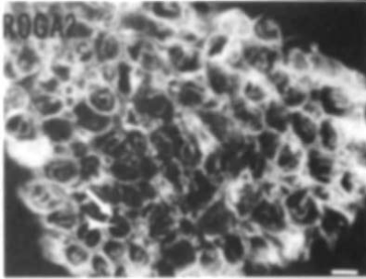
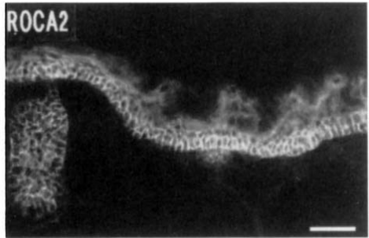

DEVELOPMENTAL DYNAMICS 197:941106 (1993) (images above)

Procedures: Acetone fix (-20C, 10 minutes), Triton permeabilization (10 minutes, R.T.).

Results:
20x3x zoom:
-With CD-9 (A, B): Some membrane labeling, but it looks similar to background results seen before.
-Secondary alone control (C): Very little labeling.
40x2x zoom:
-With CD-9: very little labeling.

Analysis: I am not convinced by the membrane-y labeling that was observed in (B). I have another CD-9 antibody, which should be tried. Other options are performing the antibody on live tissue or fixed but un-permeabilized tissue.
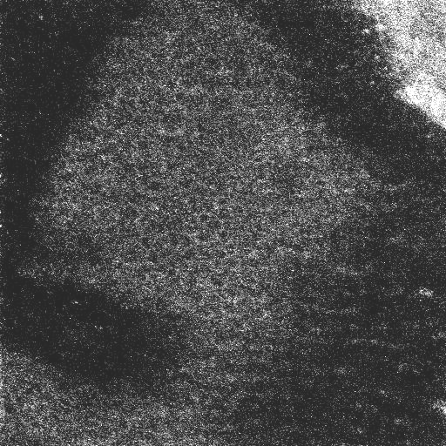
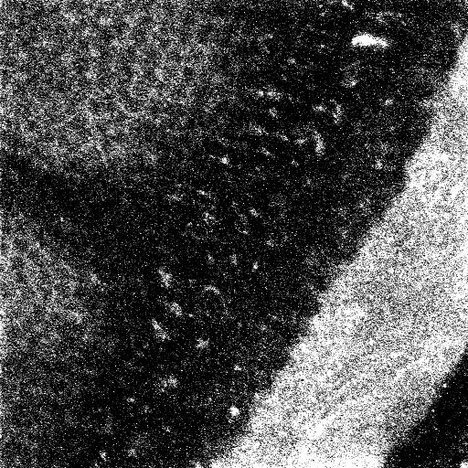
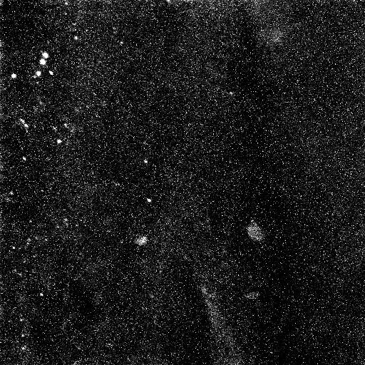

B

D

A

C

A

B

C

Developmental Studies Hybridoma Bank Collagen II Monoclonal Antibody

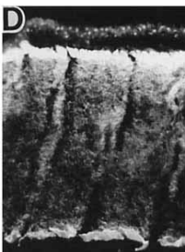
Relevance: Collagen II is a fibril forming basement membrane protein.
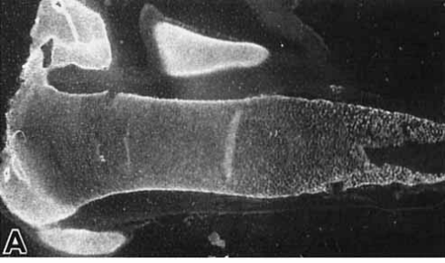

DEVELOPMENTAL DYNAMICS 196: 47-53 (1993)) (above)
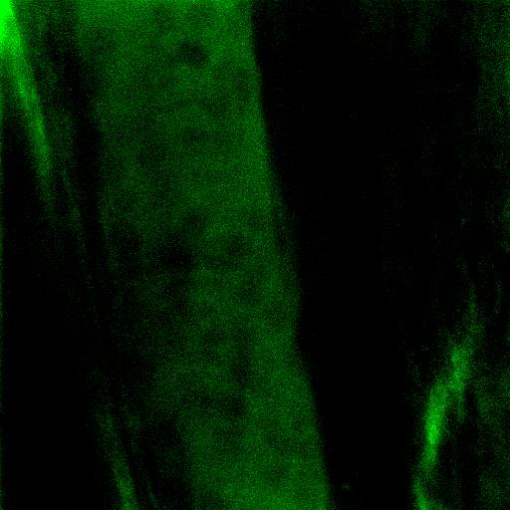
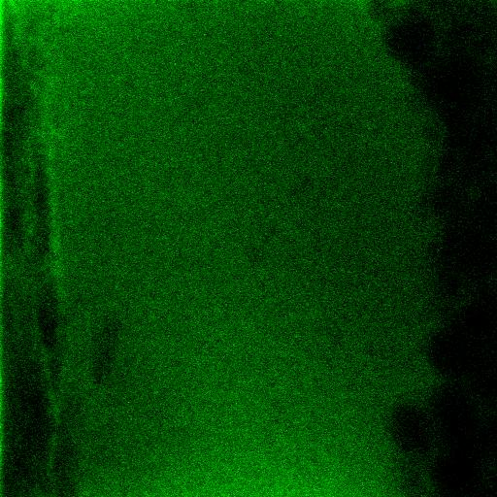
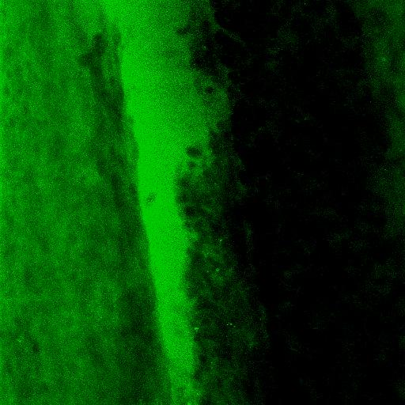
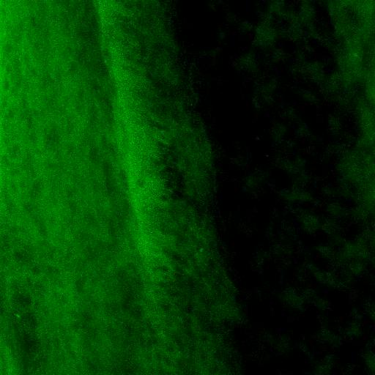
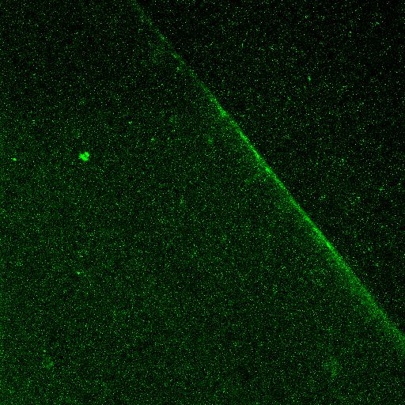
A

C

B

D

E

Procedures: Used isolated basement membrane. Paraformaldehyde fix, no triton. The dissection was a little difficult because the cartilaginous plates sometimes bended over the tissue. However, enough basement membrane was visualized.

Results:
40x: -With Collagen II antibody (A,B): Bright matlike basement membrane labeling (A), above fibril like basement membrane labeling (B).
-Secondary alone control (E): Very little fluorescence.
40x3xz:
-With Collagen II antibody (C,D): similar trends, noted above.

My only uncertainty is that of what the hazy labeling is. However, I have little doubt that this was a positive result with the distribution that we would have expected.
A

B

C

Developmental Studies Hybridoma Bank Decorin Monoclonal Antibody

Relevance: Decorin is a fibril forming basement membrane protein. This protein is a component of connective tissue, binds to type I collagen fibrils, and plays a role in matrix assembly. It contains one attached glycosaminoglycan chain.
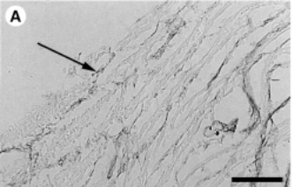

1999 Poultry Science 78:1619–1626)) (above)
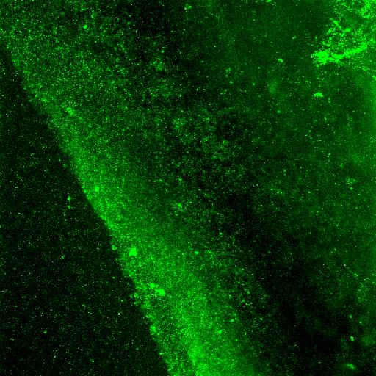
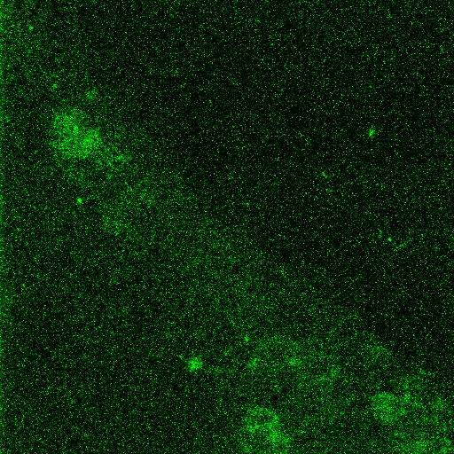
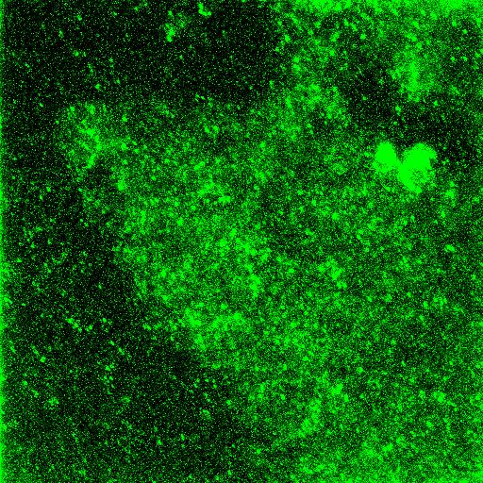
A

D

C

B

C

Procedures: Used isolated basement membrane. Paraformaldehyde fix, no triton. The dissection was a little difficult because the cartilaginous plates sometimes bended over the tissue. However, enough basement membrane was visualized.

Results:
40x: -With Decorin (A): Bright matlike basement membrane labeling (A).
-Secondary alone control (C): Very little fluorescence.
40x3xz:
-With Decorin antibody (B): “Decoration-like” labeling pattern starts to be observed.
-Secondary alone control (D): background fluroescence.

I have little doubt that this was a positive result with the distribution that we would have expected.
A

B

C

