Lab #2 Electron Diffraction Data Analysis 1
Original Data, in imperical units and conversion to metric 1
Calculation of extrapolated height for a flat surface tangent to center 2
Calculation of the lattice spacing in the graphite along with the error 4

Lab #2 Electron Diffraction Data Analysis
close all, clear all, clc;

Original Data, in imperical units and conversion to metric
along with determination of mean heights and standard error

ring_height_in=[0.839 1.576 0.945 1.662 0.966 1.780 1.023 1.944 1.181 2.064
0.856 1.559 0.909 1.651 0.976 1.753 1.044 1.960 1.133 2.022
0.882 1.580 0.922 1.681 0.946 1.778 1.059 1.963 1.173 2.021
0.895 1.575 0.928 1.652 0.942 1.784 1.063 1.976 1.127 2.031
0.898 1.586 0.960 1.655 0.973 1.736 1.024 1.941 1.156 2.051
0.859 1.595 0.913 1.659 0.984 1.748 1.021 1.938 1.128 2.061
0.863 1.572 0.891 1.664 0.988 1.759 1.022 1.956 1.161 2.054
0.886 1.582 0.915 1.662 0.942 1.781 1.039 1.941 1.131 2.064
0.884 1.580 0.922 1.661 0.981 1.755 1.052 1.936 1.121 2.072
0.871 1.599 0.914 1.662 0.939 1.766 1.026 1.947 1.101 2.003 ];

ring_height_m=ring_height_in.*0.0254;
mean_ring_height=mean(ring_height_m)
SE_ring_height=std(ring_height_m)./sqrt(length(ring_height_m(:,1)))

mean_ring_height =

Columns 1 through 9

0.0222 0.0401 0.0234 0.0422 0.0245 0.0448 0.0263 0.0495 0.0290

Column 10

0.0519

SE_ring_height =

1.0e-003 *

Columns 1 through 9

0.1520 0.0916 0.1546 0.0674 0.1563 0.1315 0.1313 0.1046 0.2035

Column 10

0.1871

Calculation of extrapolated height for a flat surface tangent to center
of the diffraction tube

h0=mean_ring_height./2; % I used 1/2 the height so that the geometry of the
% triangles is a simpler calculation for only one side
h=.1315*tan((1/2).*asin(15.15151515.*h0))
error_h=.002*tan((1/2).*asin(15.15151515.*h0)); %I am using the error in
%the length of the manufacturing of the tube for this calculation because
%the Standard Error of the measurements is negligible relative to the
%manufacturing error of plus/minus 2mm
D=2*h % Converting back to the entire form
error_D=2*error_h;
VA=[5000,5000,4500,4500,4000,4000,3500,3500,3000,3000];
root_VA=sqrt(VA);
hold on
errorbar(root_VA(1:2:end),D(1:2:end),error_D(1:2:end))
errorbar(root_VA(2:2:end),D(2:2:end),error_D(2:2:end),'g')
title('Ring Diameter vs. Square Root of Anode Voltage');
xlabel('sqrt(V)'), ylabel('D (meters)');
legend('Inner Ring','Outer Ring');
hold off
L=.13; h_bar=1.055e-34; c=2.998e8; e=1.602e-19; m=9.109e-31;

h =

Columns 1 through 9

0.0111 0.0205 0.0118 0.0216 0.0123 0.0230 0.0133 0.0256 0.0146

Column 10

0.0270

D =

Columns 1 through 9

0.0223 0.0410 0.0235 0.0432 0.0246 0.0460 0.0265 0.0512 0.0292

Column 10

0.0539

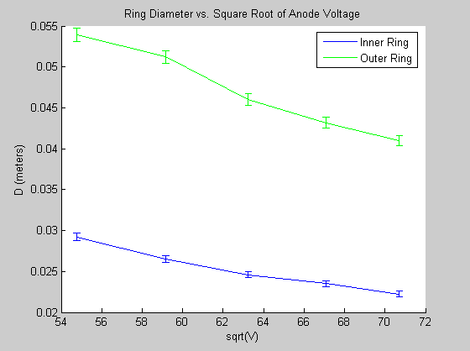

Calculation of the lattice spacing in the graphite along with the error
in the calculation of the spacing

d_inner=(4*pi*L*h_bar*c)./(D(1:2:end).*sqrt(2*e*VA(1:2:end)*m*c^2));
d_outer=(4*pi*L*h_bar*c)./(D(2:2:end).*sqrt(2*e*VA(2:2:end)*m*c^2));
lattice_spacing=[mean(d_outer),mean(d_inner)] %I have it in this order because
% the data shows that d_outer is greater than d_inner
% once again I am using the error in the constuction of the tube because it
% is of a minimum order 10^10 greater than the standard error of the mean
L_error=.002;
d_error=((4*pi*(L+L_error)*h_bar*c)./((D-error_D).*sqrt(2*e*VA*m*c^2))-...
(4*pi*(L-L_error)*h_bar*c)./((D+error_D).*sqrt(2*e*VA*m*c^2)))/2;
d_in_error=mean(d_error(1:2:end));
d_out_error=mean(d_error(2:2:end));
lattice_error=[d_out_error,d_in_error]
% finding the percent error of the lattice spacing against known values
Actual_spacing=[.123,.213]*1e-9;
percent_error=(Actual_spacing-lattice_spacing)./Actual_spacing*100
% percent error of closest values within error of calculations
lattice_close=lattice_spacing+lattice_error
close_percent_error=(Actual_spacing-lattice_close)./Actual_spacing*100

lattice_spacing =

1.0e-009 *

0.1087 0.2025

lattice_error =

1.0e-011 *

0.3325 0.6198

percent_error =

11.6526 4.9152

lattice_close =

1.0e-009 *

0.1120 0.2087

close_percent_error =

8.9491 2.0055

