CHE 575: Tissue Engineering

*NOTE, this syllabus is posted on the course website (http://openwetware.org/wiki/ChemEng_575) and is updated throughout the semester. Check online for the most up-to-date information!)

Instructor

Professor Shelly Peyton

Chemical Engineering Department

speyton@ecs.umass.edu

LSL N531
Telephone: 545-1133
Office hours: by appointment

Course Description and Objectives
This senior and graduate co-listed course will introduce concepts of engineered tissue replacements and tissue model systems for basic research. We will discuss the growing need for tissue replacements, in vivo cell-matrix relationships in biology, and how we can engineer biomaterials (both bioinert and bioinstructive) to act as cell scaffolds.

Course Outcomes
The expected outcomes for the students of this course are:
- To understand the growing need for tissue replacements, the evolution of the field of Tissue Engineering, where it originated, and perspectives on the future of the field and potential impacts on society.
- To learn what engineering companies are at the forefront of tissue engineering, and where job opportunities exist for Chemical Engineers to work in this field.
- To understand the extracellular matrix and the chemical and physical properties of biomaterials that can guide cell survival, adhesion, migration, and differentiation.
- To use quantitative engineering approaches to understand and design engineered tissues.
- To develop skills in scientific writing, information dissemination/presentation, literature review, and collaboration through a grant writing project.
- To create a wiki page and present a novel tissue engineering tool or device.

Course Logistics
Lectures are scheduled on Tuesdays and Thursdays, 4-5:15pm, LGRT 173

Textbooks and Other Materials
There are no required textbooks for this class

Textbooks that might be helpful as references (and are available at the Library) are:
Tissue Engineering: by Saltzman, Oxford University Press (2004)
Molecular Biology of the Cell, by Alberts et al.
Biology for Engineers, by Johnson
Molecular Cell Biology by Lodish et al.
Principles of Polymer Chemistry by Flory

Course Website
http://openwetware.org/wiki/ChemEng_575

Assignments
- Readings: It is critical that you keep up with the reading assignments, as class lectures will give overviews of the reading with an additional focus on recent advances in the field of bioengineering. Readings come from current literature (research papers) and wiki pages by current and previous classes.
- In-Class Literature Review: During some classes, we will be reviewing journal articles as a group. Grading will be based on pre-class preparation, ability to lead discussion of the article, and participation.
- Wiki Pages: Each class member will research one topical area of tissue engineering, create a wiki page on that topic, and do a short research presentation in class. http://openwetware.org/wiki/575_Wikis.
- Research Project: There will be a group research project consisting of writing an NIH-style grant, and a research presentation.

Examinations
There are no examinations in this class.

Grading
This course will NOT BE CURVED. Numerical grades will be assigned for each homework assignment, examination, and project. Your final grade will be computed based on your performance in all aspects of the course with weights as follows:
Numerical Grade Corresponding Letter Grade
Research Project 50% 94-100 A
Wiki Pages & Presentation 20% 90-93 A-
In Class Literature Review 30% 87-89 B+
84-86 B
80-83 B-
77-79 C+
74-76 C
70-73 C-
60-69 D
0-59 F
Extra credit opportunities are available through extra wiki pages/presentations.
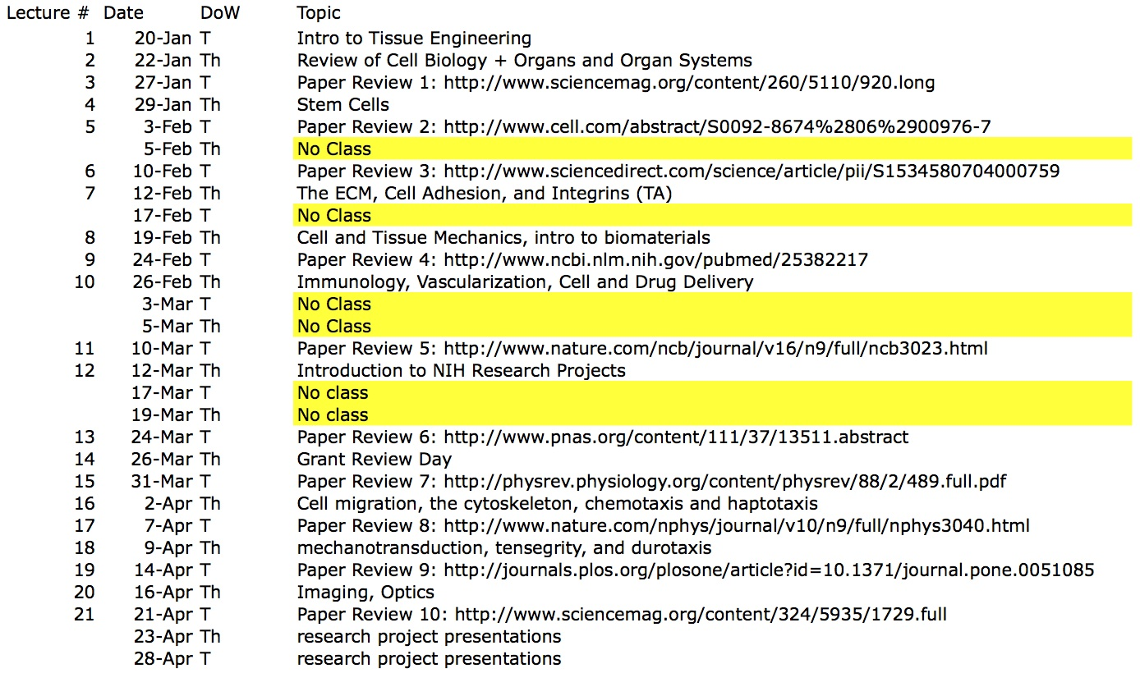

Academic Honesty
Each student is responsible for all individual assignments. The University policy on academic honesty will be strictly enforced. The details of this policy as well as examples of violations are outlined in the “Undergraduate Rights and Responsibilities” document. Further information can be found at http://www.umass.edu/dean_students/codeofconduct/acadhonesty/

Accommodation Policy Statement
The University of Massachusetts Amherst is committed to providing an equal educational opportunity for all students. If you have a documented physical, psychological, or learning disability on file with Disability Services (DS), Learning Disabilities Support Services (LDSS), or Psychological Disabilities Services (PDS), you may be eligible for reasonable academic accommodations to help you succeed in this course. If you have a documented disability that requires an accommodation, please notify me within the first two weeks of the semester so that we may make appropriate arrangements.

