&&Get CD
Osirix import files from CD by pressing the button in the top left corner that looks like a cd

Right Click on the CT File Click on anonymize.
Save CT onto Data6 in top directory for patient as TS***_CTSDE or TA***_CTSDE (etc)

&&Also export all of MR Scan with electrodes

Open X11 terminal window.

cd /Volumes/data6/TA***/afni

to3d ../TA***_CTSDE/BRAIN\ WO\ CONTRAST\ CT/STEALTH\ \ 2.0\ \ H70h\ -\ 3/*.dcm

$$Change prefix in bottom right corner of window that pops up to TA***_CTSDE
Check the x-axis centered
y-axis centered
z-axis centered buttons
Click “Save Dataset” bottom right corner
Back to terminal
3dAllineate -base TA***anatr1+orig -source TA***_CTSDE+orig -prefix TA***CTSDE_REGtoanatr1 -verb -warp shift_rotate -cost mutualinfo -1Dfile TA***CTSDE_REGtoanatr1Xform

cd ../
type in ./@TA*** to open AFNI and SUMA linked.
Change underlay to TA***CTRegtoanatR1
To turn off lines that appear on CT underlay:
Click the control surface button, uncheck everything. Save and return.

In new terminal:
cd /Volumes/data6/TA***/afni
mkdir Electrodes
chmod –R 777 Electrodes
cd Electrodes
Decide which grid/strip to pick points for.
Create new txt file with name for that grid/strip
For example: To create file for Left Lateral Frontal Grid:
touch LLF.1D
Open said file in textedit:
open –e LLF.1D
for first line in each .1D file, type #spheres
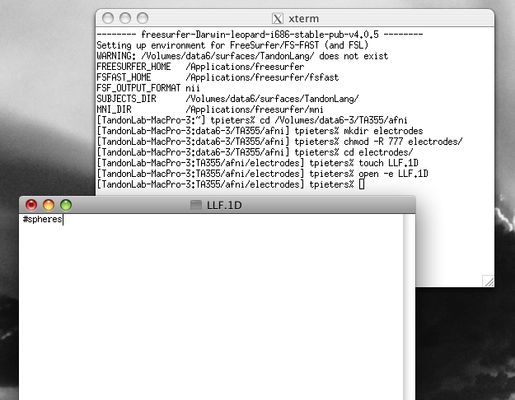
Back to CT.
Open Axial, Sagittal, and Coronal Slices. Use all three to triangulate center of each electrode, starting with Electrode 1 on each grid or strip.

To see electrodes clearly:
Open most relevant plane (for LLF, would be Sagittal slice)
Click Disp. In bottom left corner.
Change “Project:” to Maximum.
Change Slab+/- to 10 (adjust as necessary)
This will project the maximum value for 10 slices in either direction of the plane you are in. Electrodes project a very high value, so this tends to make them stand out very clearly
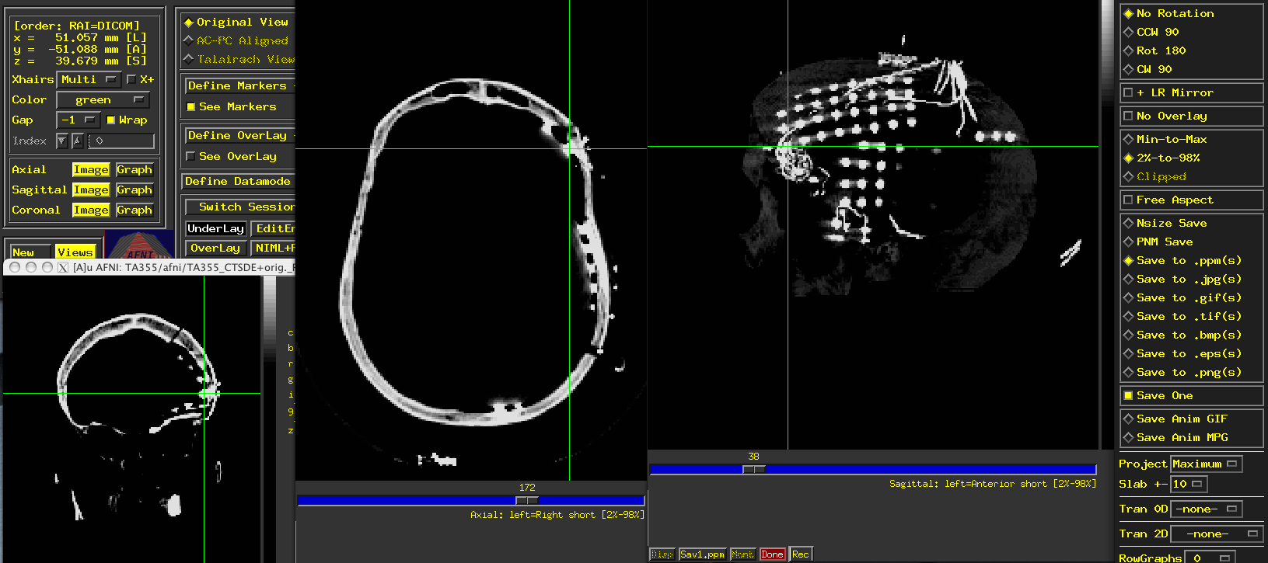

On main control screen in AFNI:

Once points are picked, read the XYZ coordinates and type them into textedit window that is open. With spaces between and followed by an x.
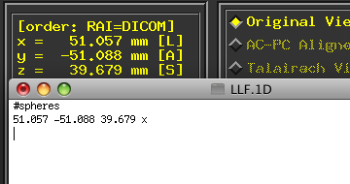
Move onto and repeat for each additional electrode , staying in numerical order.

Once every electrode for grid is picked out, command+f to find and replace all x’s with 1 1 1 1 1.5 2
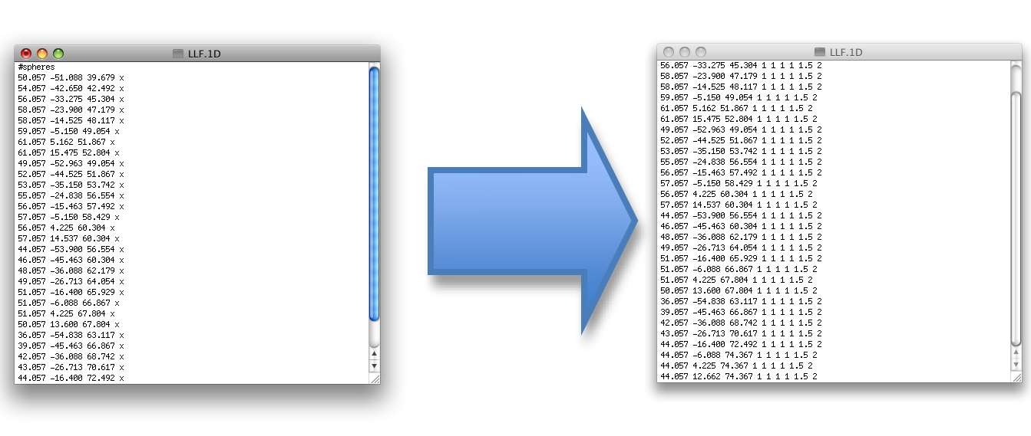

Save and close text file.
Repeat for remaining grids and strips.

Once all grids and strips are picked out go back to the terminal window and run the following code (being sure that you are in the Electrodes directory):

cat *.1D > TA***_lh_grids Be sure to enter the patient number for the stars
mv TA***_lh_grids TA***_lh_grids.1D
open –e TA***_lh_grids.1D

Delete all #spheres except for the first one. Be sure there is no white space at the bottom of the file.

In AFNI:
Define underlay as TA***anatr1.
Open axial plane.
Locate approximate point halfway between Anterior and Posterior Commisure
Write down approximate x y and z coordinates for this point.
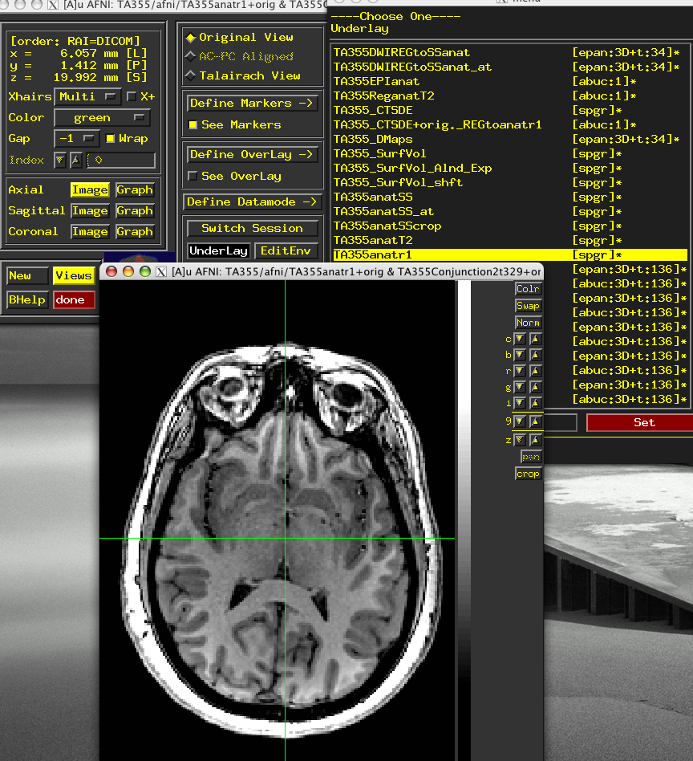
Open MATLAB

cd /Volumes/data9/matlab/ORStim_functions
double click on ct_localize.m on left of screen to edit briefly.
Change all places where TA*** is seen so that relevant patient number is shown.
Change x1, y1 and z1 to match the coordinates you picked for the point between the anterior and posterior commisure.
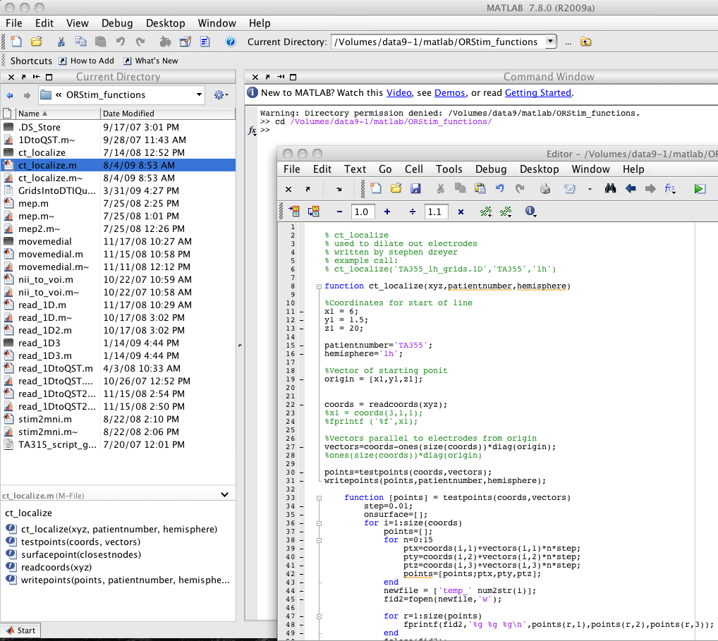

Run matlab code with TA***_lh_grids.1D as the first input and the relevant information for the other two.

Open SUMA.
Control+command+s
Under directories double click Electrodes
Under Files, double click TA***_lh_electrodes.1D
