**SEED Academy, Spring 2011**

**Synthetic Biology Module**

*Homework #5*

*Due March 26, 2011*

1. **Laboratory Project Overview**

Here is our lab schematic (adapted from MIT’s 20.109 DNA Engineering Module: <http://openwetware.org/wiki/20.109(F08):Module_1>). Please answer the question(s) that follow(s).

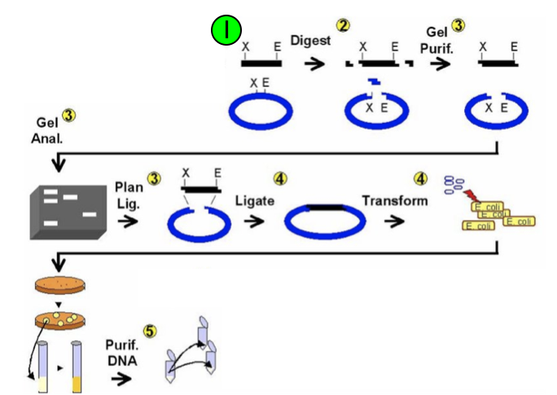

1. You will “Ligate” and “Transform” on Day 6. What are the “blue” and “black” pieces of DNA that you will be working with for these steps? Gives names and brief descriptions (e.g. J23100, constitutive promoter…)
2. **Transformation Prep Question**
   1. Use wikipedia to find the molecular biology definition of “Transformation.” Read the description and tell us what this process is in YOUR OWN WORDS.
   2. Describe two methods in which we can make cells competent for transformation and how the cells are treated during transformation. (Hint: also on wikipedia. If we are making them competent, they don’t have this ability natively.)
   3. Think back to quiz #1 on antibiotic resistance (I know it was a while ago). How do we utilize the concept of antibiotic resistance to “select” only the cells we want after transformation? (Hint: we only want cells that have the DNA we want to put into them)
   4. Look up the plasmid pSB4A5 that we are using from the parts registry (<http://parts.mit.edu/registry/index.php/Part:pSB4A5>). What antibiotic resistance does the plasmid pSB4A5 have?
   5. A replication origin is required for plasmids to replicate inside cells. What is the name of the origin in pSB4A5?
   6. Again, think back to the first day in lab and the first quiz. In biology, we have a hard time looking at just one cell to make sure it is what we want. What method should we use to make sure that all of the bacteria we pick are the same (or mono-clonal)?